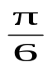
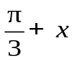
1 | Using sine rule,  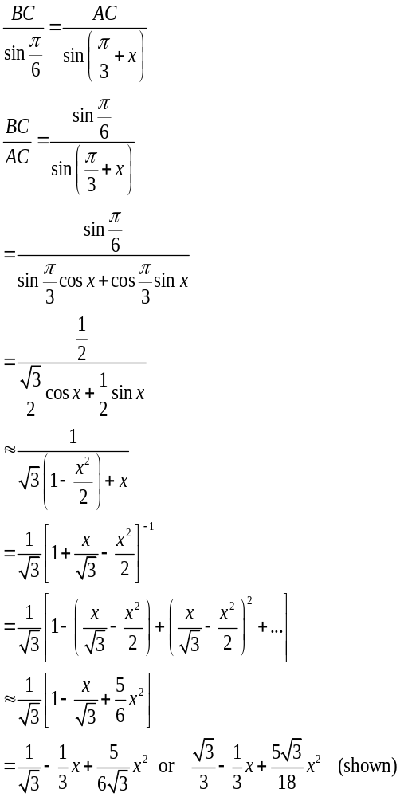  Hence, a = , b = - , c = (Ans).
2 | (i) 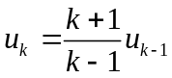  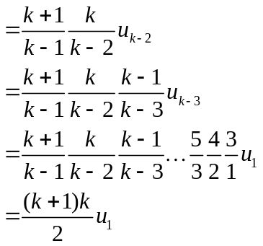  (ii) Let P(n) be the statement “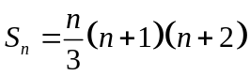 for all positive integer 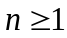”  When n = 1,  L.H.S = 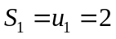  R.H.S = 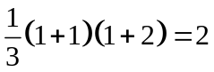  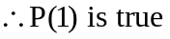  Assume P(k) is true for some 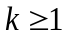, 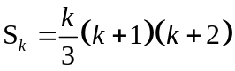  To prove P(k+1) is true:  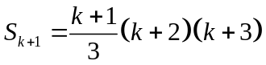  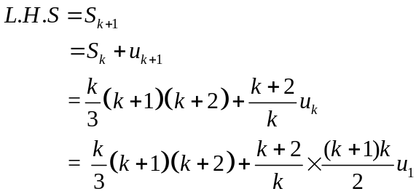  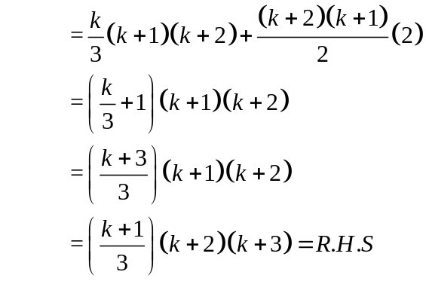  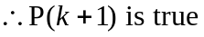  Since P(1) is true and P(k) is true implies P(k+1) is true, by Mathematical Induction, P(n) is true for all 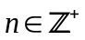.
3(i) | 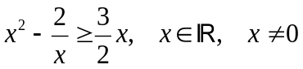  ⇒ 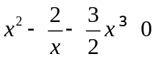  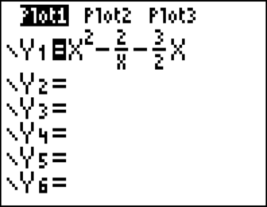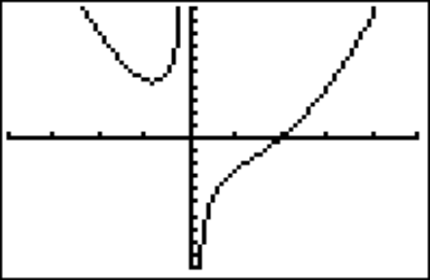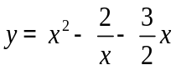Method 1:Using GC to sketch the graphs of 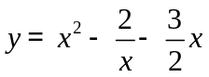 .  0  2  From the graph: 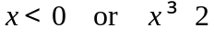  Method 2:  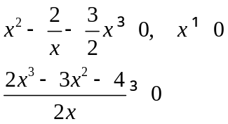  Multiplying by 2x², 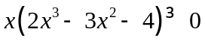  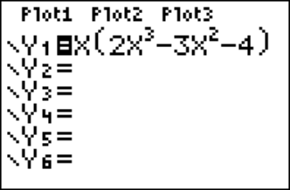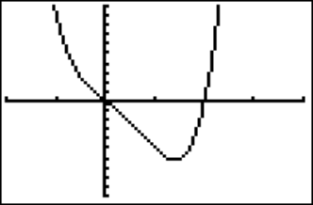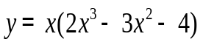Sketch the graph of 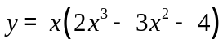 using GC:  0  2  From the graph:  Method 3: Analytical method  Multiplying by 2x²,  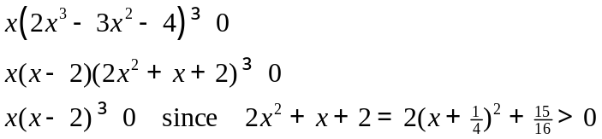
(ii) | 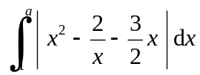  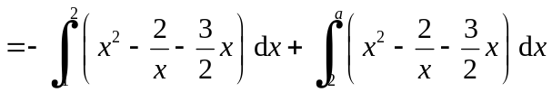  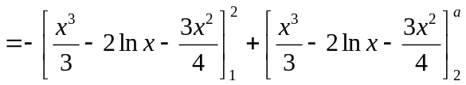  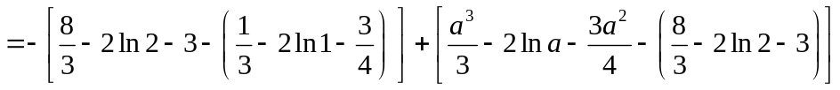  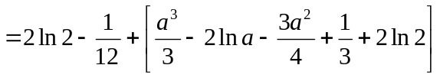  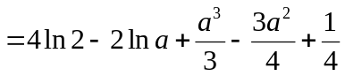  ∴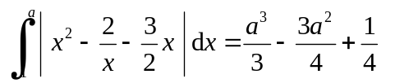  ⇒ 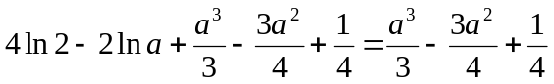  ⇒ ln 2⁴ = ln a²  ⇒ a = 2² = 4.
4 | (i) 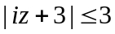  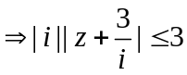  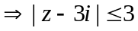  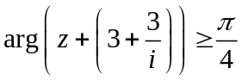  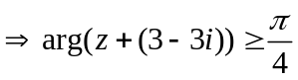  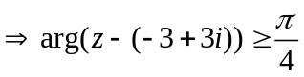    (ii)  (a)  Min |z - (3+3i)|=PT  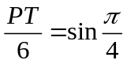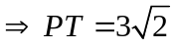  Max possible |z - (3+3i)|=QT = 6 units, but Q is not to be included.  Therefore 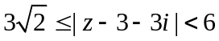 since Q is not included. (Ans)  (b)  Max 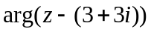occurs at point Q (not included) and min occurs at point P.  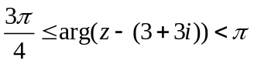 (Ans)
5 | (i)  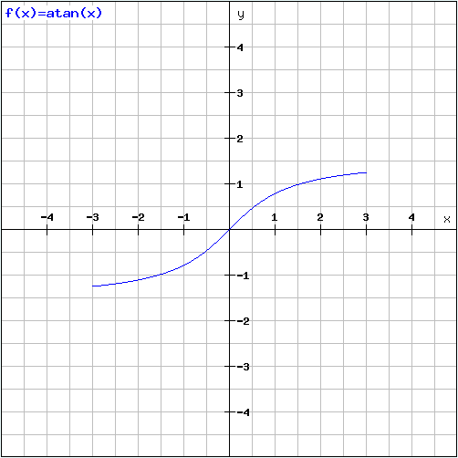  (ii)  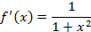  Differentiating w.r.t. x :  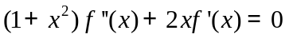  Differentiating w.r.t x:  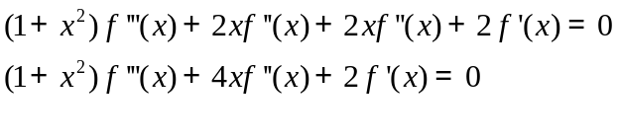  When  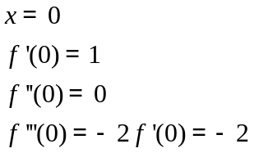  Hence  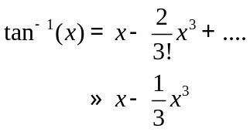  (iii)  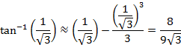  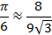  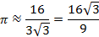  (iv)  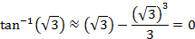  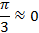  (v) The approximation in (iii) is better than that in (iv) because the value of x substituted in (iii) is closer to zero as compared to the value of x substituted in (iv).
6 | - 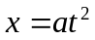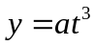  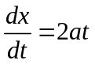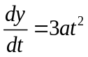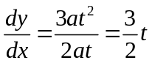  When 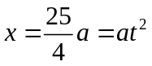, 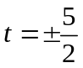  When 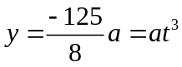, 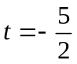. 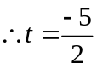 for 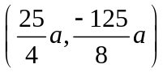  Note that 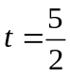 does not give the correct point.  When 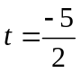, gradient of tangent 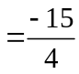,  Eqn of tangent : 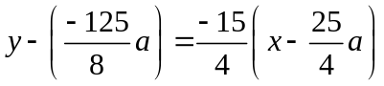  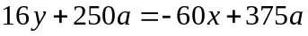  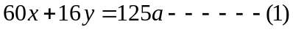  - Subst and into (1):  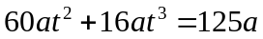  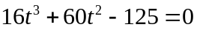  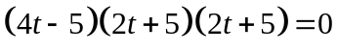  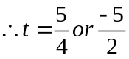  Note that is rejected.  When 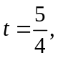 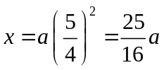, 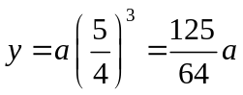,  Hence the coordinates of the point where the tangent meets the curve again is at 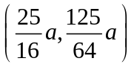  - 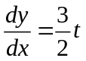, gradient of normal 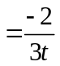  Eqn of normal : 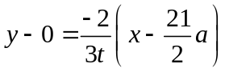  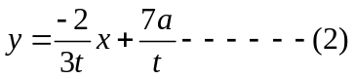  Subst and into (2):  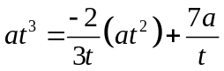  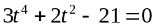  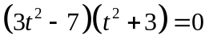  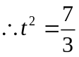 or 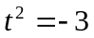(rejected)  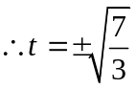  When 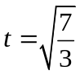, 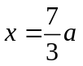, 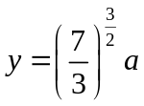,  When 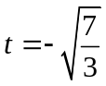, , 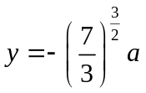,  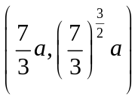 and 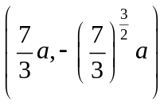
7 | 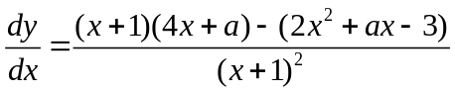  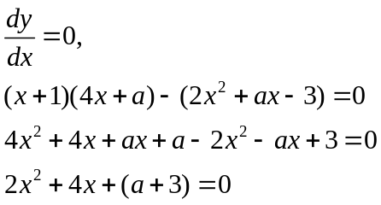  For stationary points to exist:  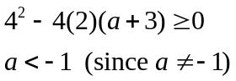  For 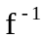to exist, there should not be any stationary point in the given domain, hence 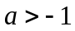.  Therefore, the set of values: 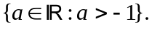
(i)
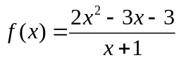
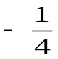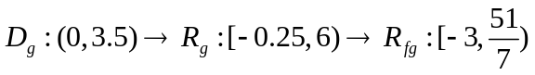
1
6
3.5
y
x

(ii)
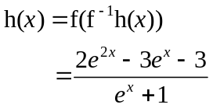
Therefore,
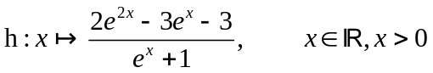

8(a) | 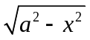  a  O x P  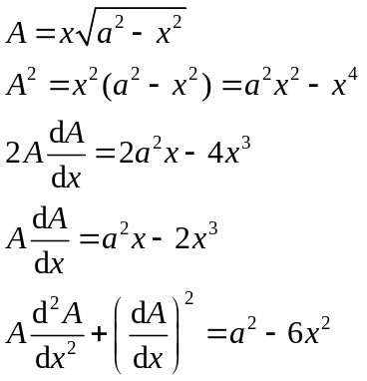  For max A, 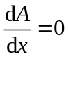  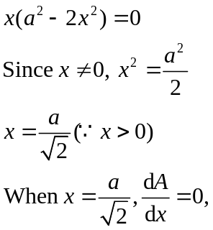  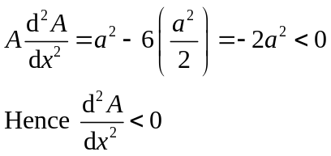  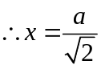 gives a max A  Perimeter of OPQR = 2x + 2  When 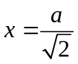,  Perimeter of OPQR  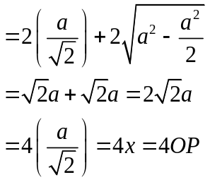
(b) | C  6 cm  P D  x cm  Let PD = x cm and 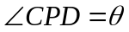 rads at any time t.  Given: 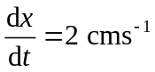,  To find 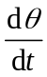 when x = 6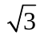cm  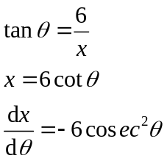  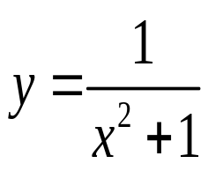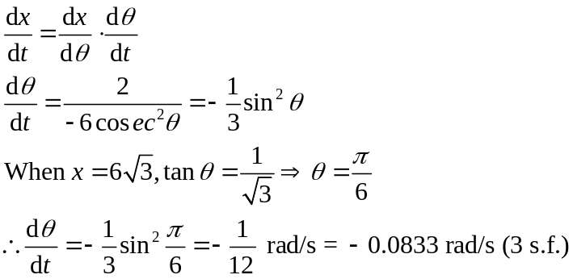  y  x  O  3  3/(n+1)  6/(n+1)  3n/(n+1)
9 | (i)  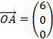 ; 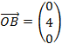 ; 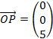 ; 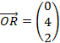 ;  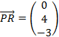  Hence the vector equation of line PR is 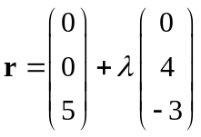, where 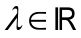.
(ii)
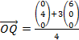 =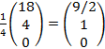
(iii)
l : 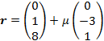, 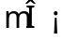
Equate: 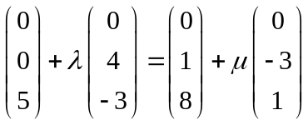
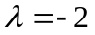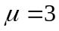
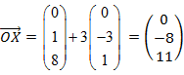

(iv)
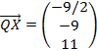
| m | = 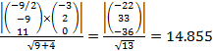
| m | is the perpendicular/shortest distance from point X to line AB.
Area of triangle AXB =
(3 s.f.)
10 | (i)  Π₁ : 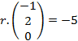 ; Let the centre of centre be M.  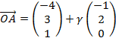 for a fixed .  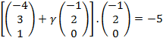  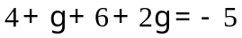  Solving for gives .  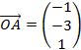  Radius= MA =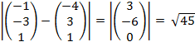 units
(ii)
Direction vector of line l₁ is =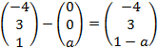
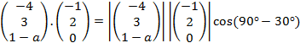

As a > 0 , a = 1+
(iii)
A vector perpendicular to Π₂: 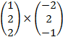 = 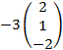
Π_{2:} 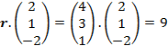

To show that Π₁ and Π₂ are perpendicular we must show that the normal between Π₁ and Π₂ are perpendicular. Hence we need to show 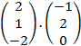 =0
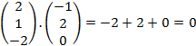
Hence Π₁ and Π₂ are perpendicular.

11 | (a)  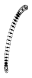  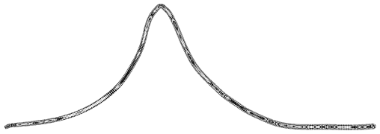  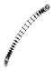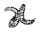  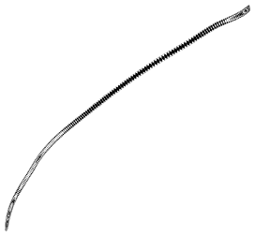  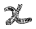  Area of Q =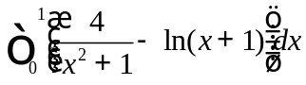  = 2.76 units²
(aii)
From the diagram in (a)
When 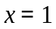, 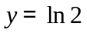(for 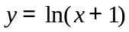)
When , 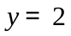(for 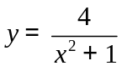)
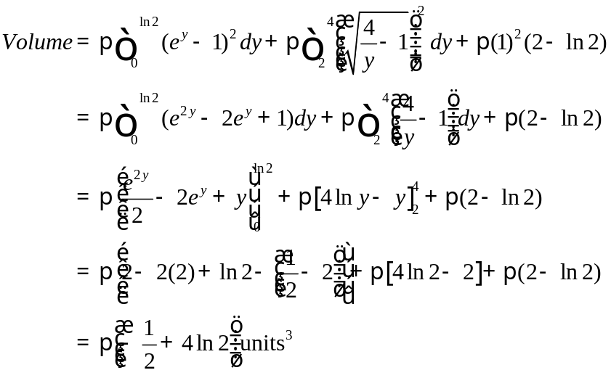
(b)
(i) Since the rectangles are an overestimation of the area under the curve, so
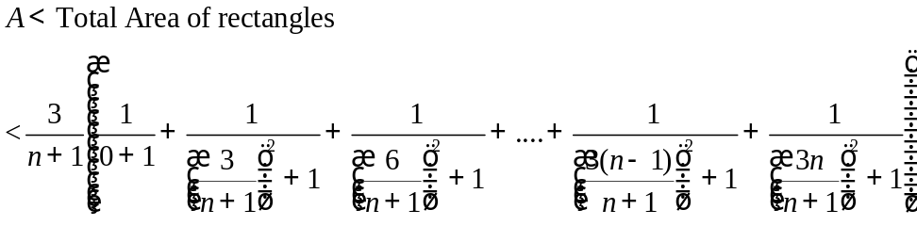

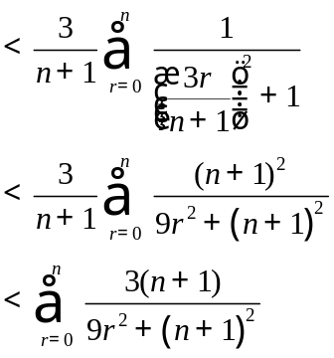
(ii)
As , the area of the rectangles
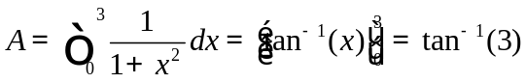

12(a) | 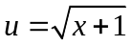 ⇒ 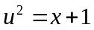 ⇒ 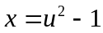  ⇒ 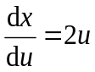  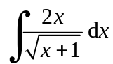  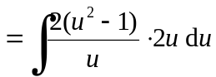  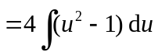  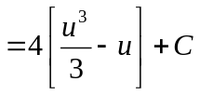  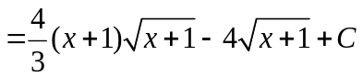
(b) | 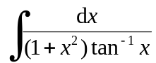 , x > 0  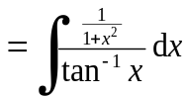  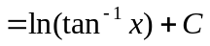
(c) | (i)  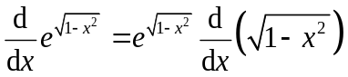  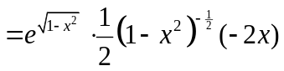  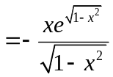
(ii)
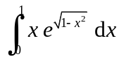
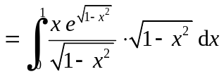
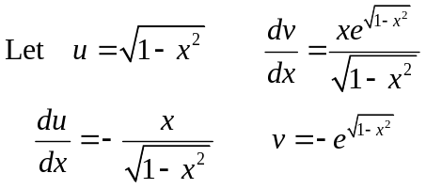

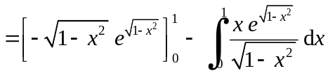
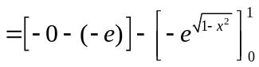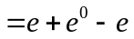
= 1
y
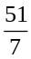
y=f(x)
y =g(x)
-1
6
x
-3

Q
R
A
B
C

